**Institutional Collaboration Grant**

**2026**

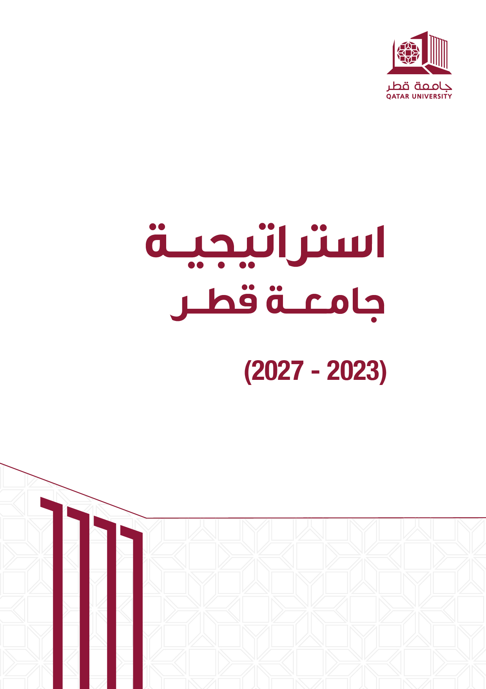

# Program Summary

|  |  |
| --- | --- |
| Please refer to the website for specific dates. | **Submission Start Date** |
| **Submission Deadline** |
| **Announcement Date** |
| Up to two years | **Project Duration** |
| 120,000 USD for 2 years  (up to 60,000 USD per year) | **Project Budget** |
| [igrants@qu.edu.qa](mailto:igrants@qu.edu.qa) | **Contact Email** |

# Program Overview

The Institutional Collaboration Grants aim to strengthen research partnerships between Qatar University and higher education institutions in the GCC countries, as well as international universities that have strategic partnerships and signed MOUs with Qatar University, including joint funding agreements. This type of grant is a key tool to expand international academic collaboration, exchange expertise, and develop research projects of mutual interest.

# Program Objectives

The Institutional Collaboration Grant for joint funding paves the way for sustainable collaboration by supporting and implementing joint research projects between Qatar University and selected universities. It aims to enhance research integration and knowledge exchange.

# Eligibility Criteria

* The project should be based on genuine collaboration between the participating institutions.
* Graduate and undergraduate students must be included in the research team to enhance their research experience.
* It is preferable to form multidisciplinary research teams that include members from research centers and academic departments at Qatar University to promote interdisciplinary collaboration.

**Please refer to the Qatar University Internal Grants Guide (Team Structure section, Application Terms and Conditions section) for more details.**

# Research Team Structure

* The proposal must include a Lead Principal Investigator (LPI) from Qatar University.
* For the remaining team members, please refer to Qatar University’s Internal Grant Guidelines (Terms and Conditions section).
* The proposal must also include another Lead Principal Investigator (LPI) from the collaborating institution.
* The structure of the research team at the collaborating institution must comply with its own internal policies and procedures.

# Proposal Submission

The application link will be shared during the grant launch announcement.

**Please refer to the Qatar University Internal Grants Guide (Electronic Platforms section, Research Proposal Submission section, Required Documents section) for more details.**

# Budget

The budget within the research proposal must be prepared accurately and realistically, adhering to the limits and regulations stated in the grant guidelines and Qatar University’s financial policies.

Qatar University and the collaborating institution jointly fund this grant. Each funding entity is directly responsible for disbursing its share of the project funding.

* The funding from each entity can reach up to 60,000 USD per year, totaling up to 120,000 USD over two years.
* Funding for the second year is conditional upon satisfactory performance in the first year and timely submission of financial/final reports.

**Please refer to the Qatar University Internal Grants Guide (Budget section, Financial Procedures and Project Management section) for more details.**

# Acknowledgement

The Lead Principal Investigator (LPI) must ensure that all publications and research outputs acknowledge Qatar University’s financial support, using the following statement:

“This [publication, poster, report, etc.] was funded by Qatar University – Institutional Collaboration Grant [Project Number].

The findings achieved herein are solely the responsibility of the researcher(s).”

# Contact Information

For inquiries, please email: [igrants@qu.edu.qa](mailto:igrants@qu.edu.qa)